INSTALLATION MANUAL

PLATFORM FORECASTS AND CLIMATE Agroclimatic

Product # 1 - USAID

WRITTEN BY:

STEVEN SOTELO

EDWARD GUEVARA

TABLE JEISON

DECISION AND POLICY ANALYSIS - DAPA

International Center for Tropical Agriculture - CIAT

CALI

2017

Table of Contents

one. BUYERS 3

1.1. HARDWARE 3

1.2. SOFTWARE 3

two. SOFTWARE INSTALLATION 4

2.1. WINDOWS 4

2.1.1. .net Core 4

2.1.2. mongo 5

2.1.3. R eleven

2.1.4. CPT fifteen

2.1.5. DSSAT 22

2.1.6. Oryza 27

3. Website settings 32

3.1. PREPARING THE ENVIRONMENT 32

3.2. WEB SITE MANAGEMENT 3. 4

3.3. API WEB SITE 37

3.4. WEB SITE VIEWING FORECASTS 38

Four. SETTING generation process FORECASTS 40

5. RECOMMENDATIONS 40

5.1. SECURITY SETTINGS 40

5.2. BACKUPS 40

# BUYERS

The requirements described below are necessary so that the platform can be available from a single server. The application can be distributed on different servers, because its architecture permits, which must be considered for this practice are the dependencies of each component[1]. Note that the process of generating forecasts if you must be located in one place with their scripts and dependencies (DSSAT and Oryza) because otherwise the agroclimatic forecasts can not be generated.

## HARDWARE

The system can be installed entirely on a server with the following characteristics[2]:

* T2.xlarge
  + vCPU: 4
  + Memory: 16 gb
  + Hard Drive: 300GB

## SOFTWARE

The software required for the platform is dependent on the operating system you choose. The platform has been successfully tested on the following operating system versions:

* Windows Server 2012 R2 with Update, Standard x64 version

In the table below you can find the tools to be installed on the server and are a prerequisite for the system to operate.

|  |  |  |  |
| --- | --- | --- | --- |
| Tool | Version | Windows | Linux |
| DSSAT | 4.6 | <http://dssat.net/downloads/dssat-v46> |  |
| Oryza 2000 | 3 | <https://sites.google.com/a/irri.org/oryza2000/downloads/new-release/download-new-version> |  |
| CPT batch | 15.05 | <http://iri.columbia.edu/~simon/CPT/CPT_batch_installation_15.5.13.exe> |  |
| .net Core | 1.0.4 | <https://go.microsoft.com/fwlink/?linkid=844461> |  |
| mongo | 3.4.5 | <https://www.mongodb.com/dr/fastdl.mongodb.org/win32/mongodb-win32-x86_64-2008plus-ssl-3.4.5-signed.msi/download> |  |
| R | 3.4.0 | <https://cran.r-project.org/bin/windows/base/R-3.4.0-win.exe> |  |
| websites | 1.0.0 | <https://github.com/CIAT-DAPA/usaid_forecast_web/releases> |  |
| Generator forecasts | 1.0.0 | <https://github.com/CIAT-DAPA/usaid_procesos_interfaz/releases> |  |
| gunzip |  |  |  |

*Table 1. General list of tools required by the platform*

Depending on the operating system that is selected as host platform may require some additional accessories.

# SOFTWARE INSTALLATION

## WINDOWS

### .net Core

Core .NET is the framework in which it was built most of the platform. This is a requirement to have previously installed Microsoft Visual C ++ 2015 Redistributable[3]. Windows installer for this framework found in section 1.2, is a packaging containing the following .NET Core Runtime Library .NET and ASP.NET Core Core Module, which are all requirements for the application to function normally . Note that during installation can be asked to restart the server and is recommended that you do not have to trouble in the future.**This component must be installed after IIS installed**.

When you start the installation process, the program required to accept the license terms and conditions. In this window you must accept the terms and conditions and press the Install button:

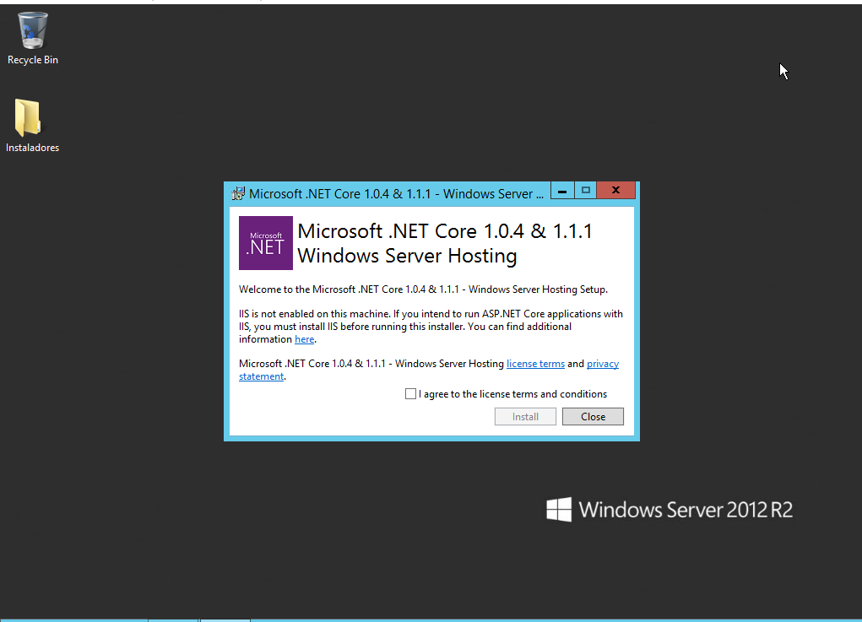

Illustration one.Net Core installation - Accept Terms and Conditions

Once the terms are accepted, the system will proceed to install the necessary components for the platform. After installation, it will show a confirmation message:

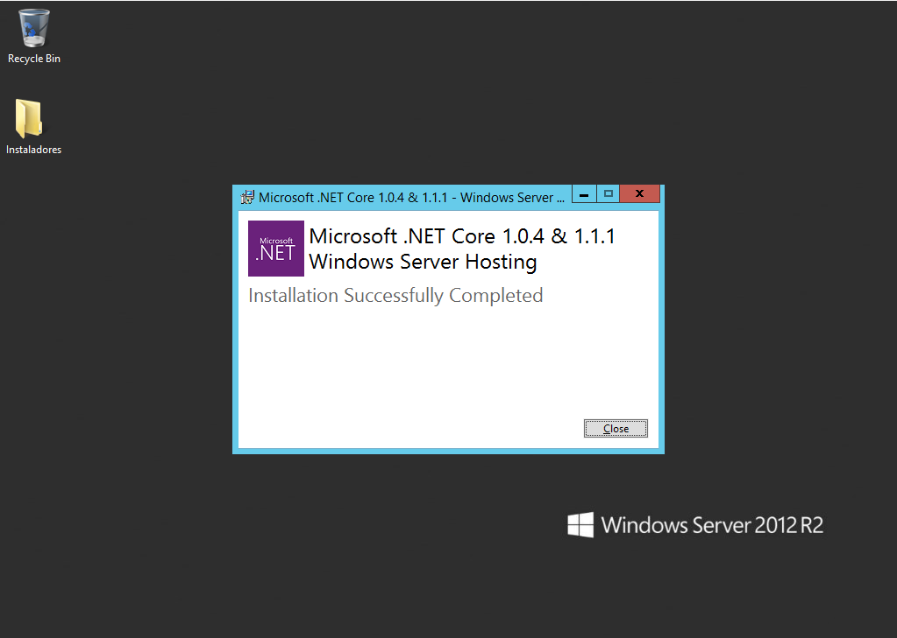

Illustration two .Net Core installation - Installation Complete

### mongo

Server database platform is picked for Mongo "Windows Server 2008 R2 64-bit and later, with SSL support x64". This database engine is no default security settings, so we recommend carefully reading Chapter 5 of this manual; This installation process should be complemented by such statements.

When you start the installation process, you will be shown a welcome screen with the details of the product version that you are installing. In this part you must press the Next button:

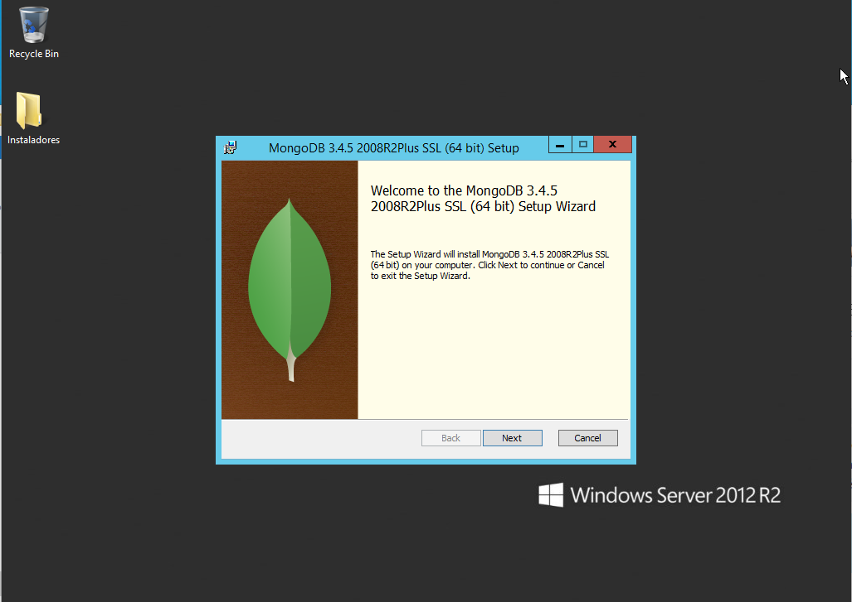

Illustration 3 Installing Mongo - Welcome

In the next window, you are prompted to accept the terms and conditions of the license. We accept the conditions and press the Next button:

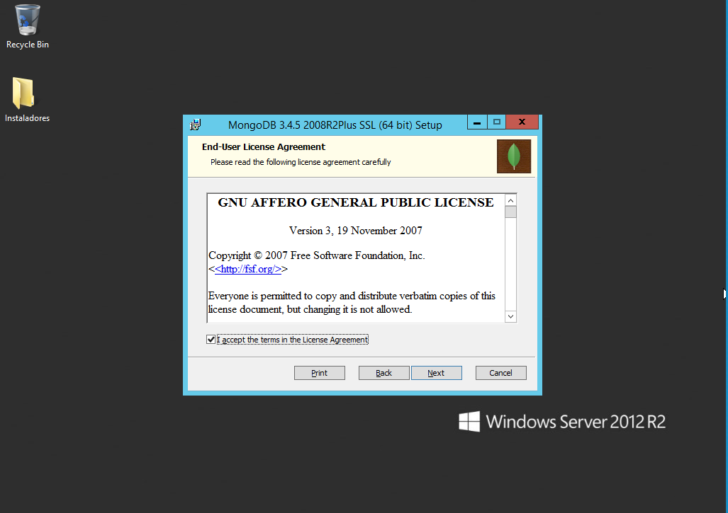

Illustration 4 Installing Mongo - Accept license

In the next window installer asks what type of installation we perform. If you are not an expert recommendation is a complete installation. Complete pressed the button:

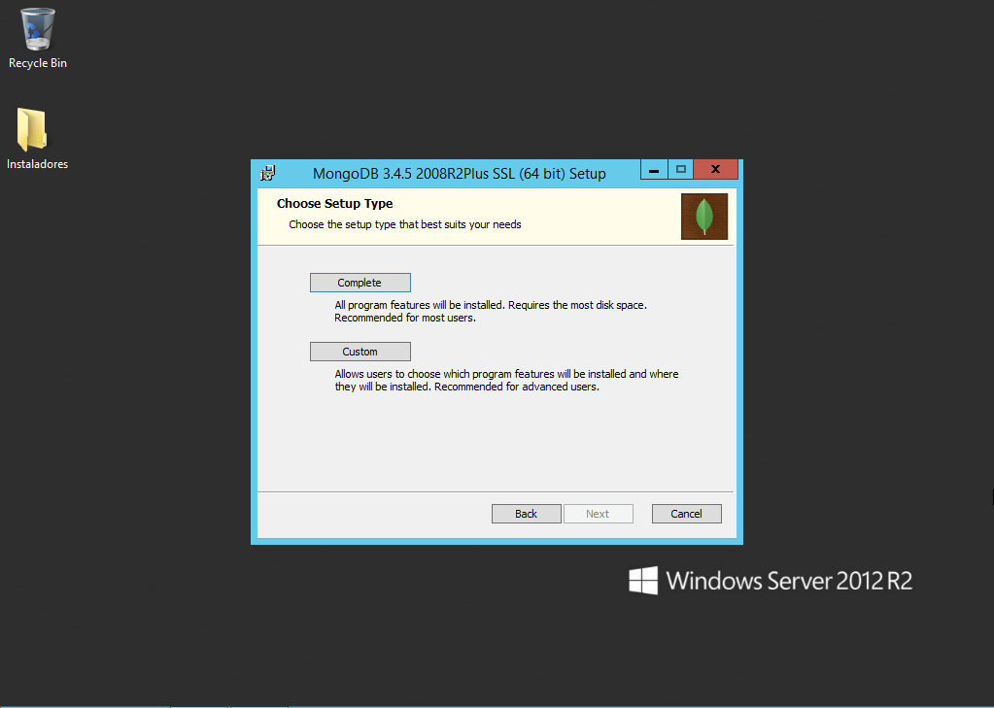

Illustration 5 Mongo installation - installation type (Complete)

The next window displays a confirmation message. Should be sure that we want to continue with the installation we proceed to press the Install button:

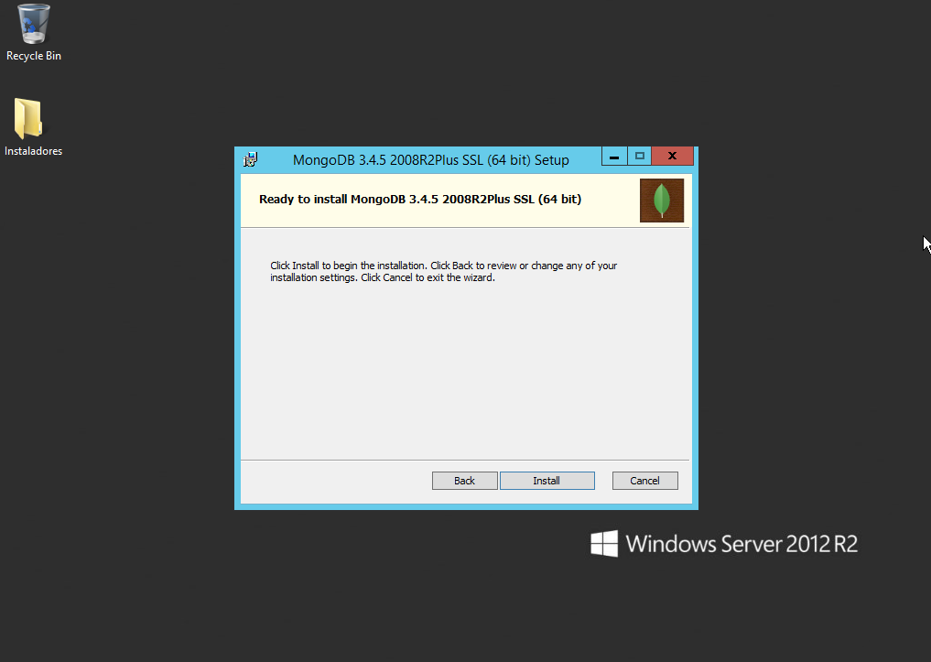

Illustration 6 Mongo installation - Installation Confirmation

The system will proceed to install all the components necessary to use the engine database. Once this has finished installing, we will display a message informing us that has already been completed and we must press the Finish button:

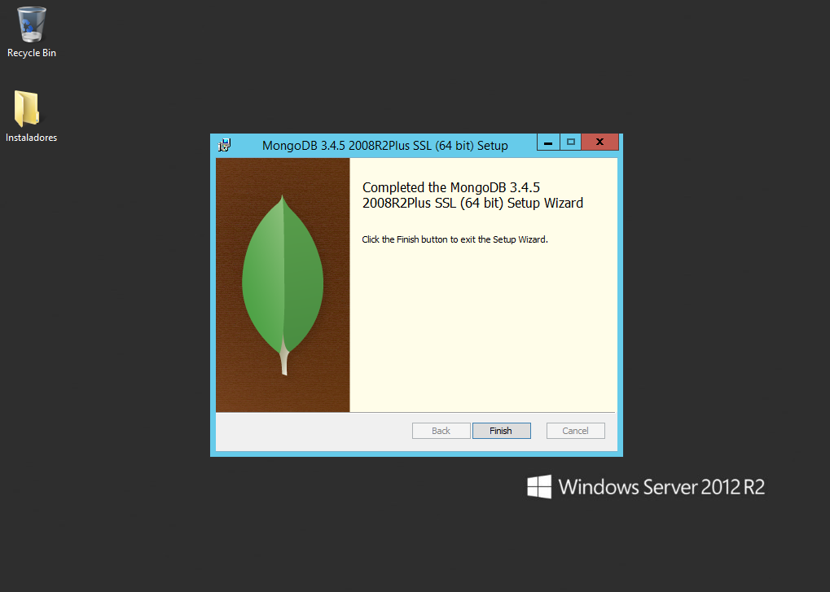

Illustration 7 Mongo installation - installation confirmation message

Once the engine components installed database, we will set Mongo as a service that can be managed from the operating system. The first thing to do is create a directory where we will store the data, logs and configuration of Mongo. For this we will create a directory on the C drive called MongoDB hard drive. Within this directory we will create three directories called log, data and conf. In the next picture you can see how it should be the organization of these folders:

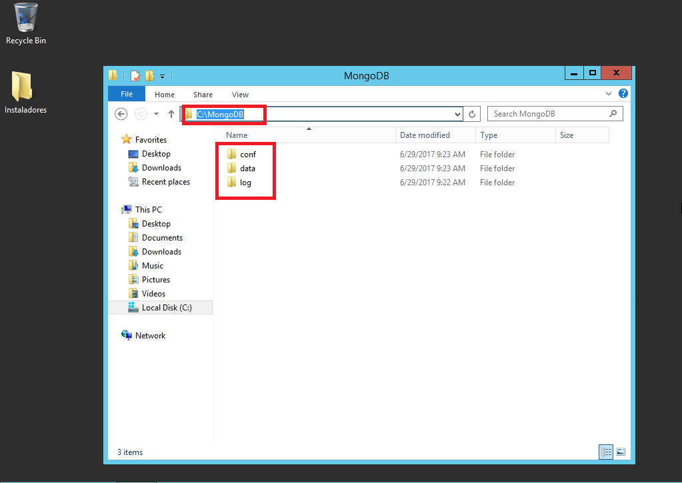

Illustration 8 Mongo settings - Organization folders

Once we have the folders we create a configuration file for Mongo. This file will contain the information necessary so that later we register Mongo as a service OS can see our settings on the engine database. To create the configuration file we open the notepad editor**[4]** and within this we will place the following information as is:

*dbpath = C: \ MongoDB \ data*

*port = 27017*

*logpath = C: \ MongoDB \ log \ mongod.log*

Once we have the contents of this file we will save in the folder you created earlier named conf mongod.conf with the name and extension. At the end, we should have something similar to the following illustration:

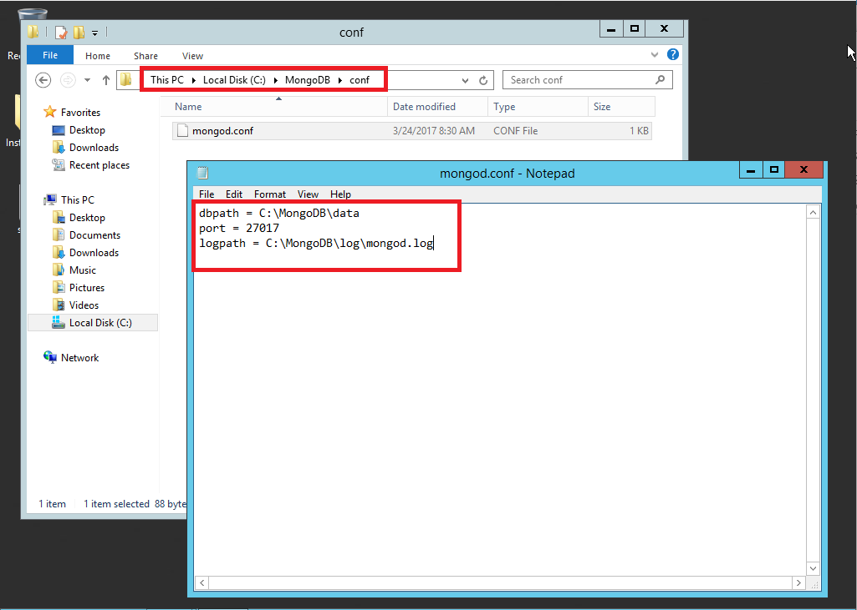

Illustration 9 Mongo configuration - Configuration File

The next step is to create an operating system service so that the service engine database automatically run. This requires first check whether Mongo has been registered in the environment variable**[5]**called Path. To check this we open a cmd window**[6]** Windows and run the following command:

*mongo*

If the variable is not set in the command console us the following message should appear:

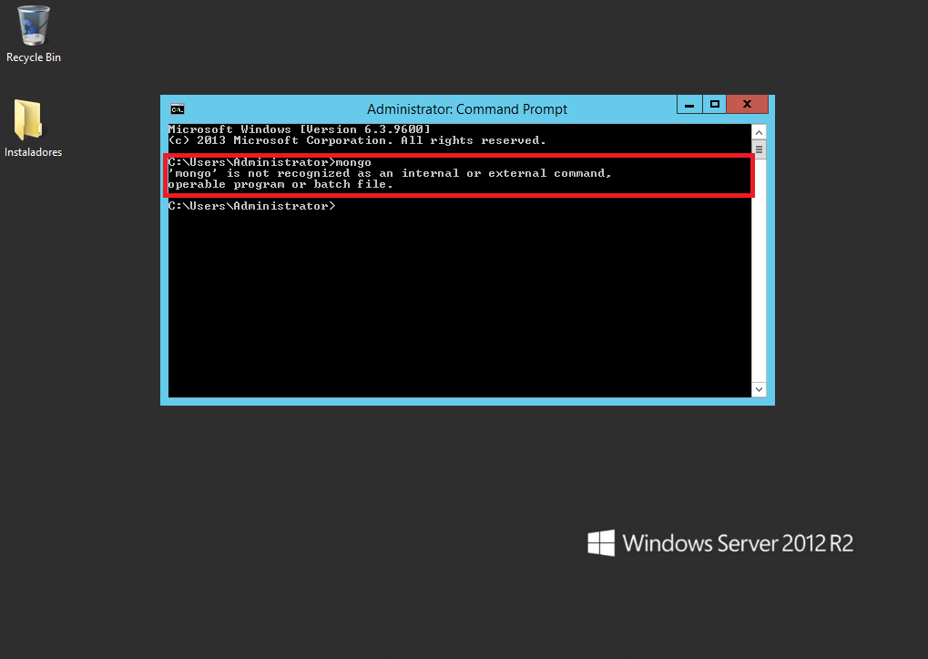

Illustration 10 Configuration Mongo - Mongo Unrecognized command

In this case we will proceed to make is to add to the Path environment variable, the path where the executable Mongo, so that as the system can recognize. For this we close the cmd window that we currently have open, then we proceed to go to the system. To achieve this we press access right click on the icon Windows Start and then look for the System option:

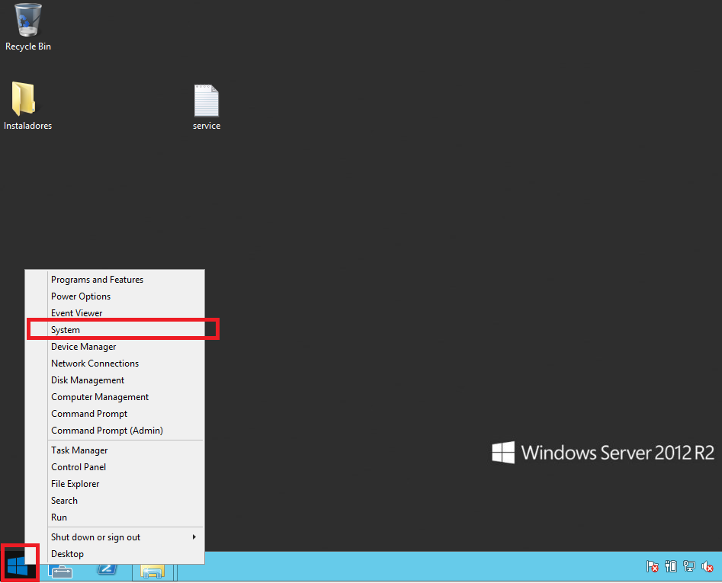

Illustration eleven Mongo configuration - Access to the system configuration

Once there, we will display a window that will indicate the current configuration and system characteristics. In the left menu you will find the Advance system settings option and press click on this. We will immediately open a new window in which search the bottom right is a button called Enviroment Variables, on which we must press click. Following this we will display a new window, where at the bottom of a list of environment variables appears; there we find the variable named Path:

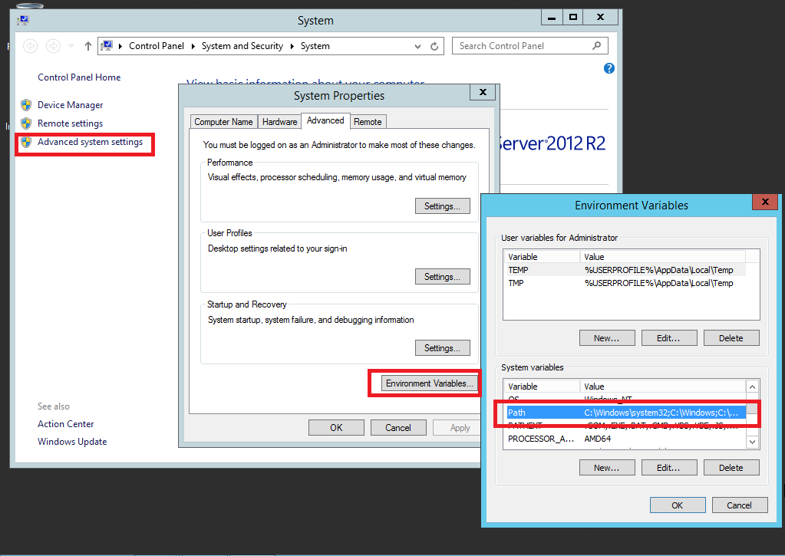

Illustration 12 Mongo configuration - Variable Path

Once we select the Path environment variable, let's click on the Edit option. We were there display a new window, where in the Variable Value option, we must turn to the end of the line and add a semicolon (;) and immediately add the path where executable files server are in Mongo, usually found in: C: \ Program Files \ MongoDB \ Server \ 3.4 \ bin however, is subject to change.**It is important that you do not alter the content that was above this field, as it may affect other programs and damage the normal functioning of the operating system, remember that it will do is add a value to what was already above.** At the end you will have something like the following:

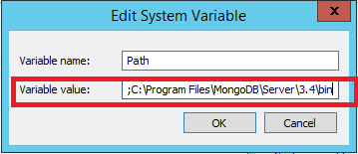

Illustration 13 Configuration Mongo - Mongo executables Add the environment variable

Once added the route Mongo files to the environment variable must accept all changes by pressing OK on all open windows above.

Now we turn to prove that the system recognizes commands using cmd Mongo, for which we opened the window of the command console and run the "mongo" command again. You should see the following message:

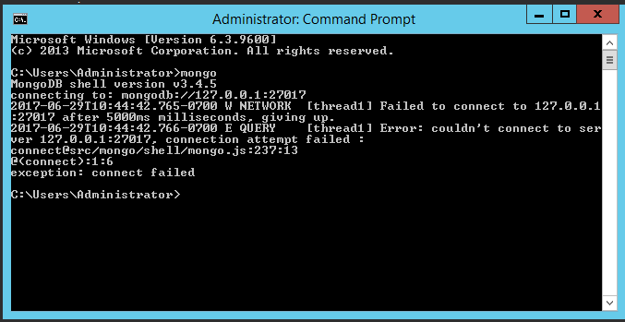

Illustration 14 Mongo configuration - Test mongo command in cmd

If you see this message, it means that we can set Mongo service on the server. The message that shows we try to say I'm trying to connect to the server database but does not see any active duty, however, this helps us to know who are already commands Mongo recognized by the system. If the message continues to appear Figure 10 we recommend that you back steps, the problem persists it is necessary to go to the official documentation software Mongo.

To create the service Mongo in the system, we must open a new window in cmd and write to the console the following command:

*mongod -f "C: \ MongoDB \ conf \ mongod.conf" --install --serviceName mdb27017 --serviceDisplayName "MongoDB Server Instance 27017" --serviceDescription "MongoDB Server Instance running on 27,017"*

When you run the command cmd we should be as follows:

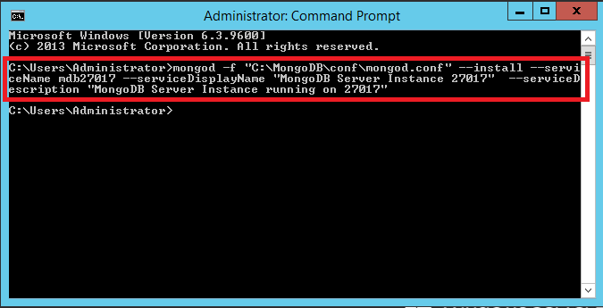

Illustration fifteen Mongo configuration - Creating Service database

Now we can review within the service system has been set up our new service. What we must do is start to become available already. For this we will open the system services[7]Once there we look for the item called "MongoDB Server Instance 27017" and press the Play button (this button has an icon shaped green arrow) in the top menu:

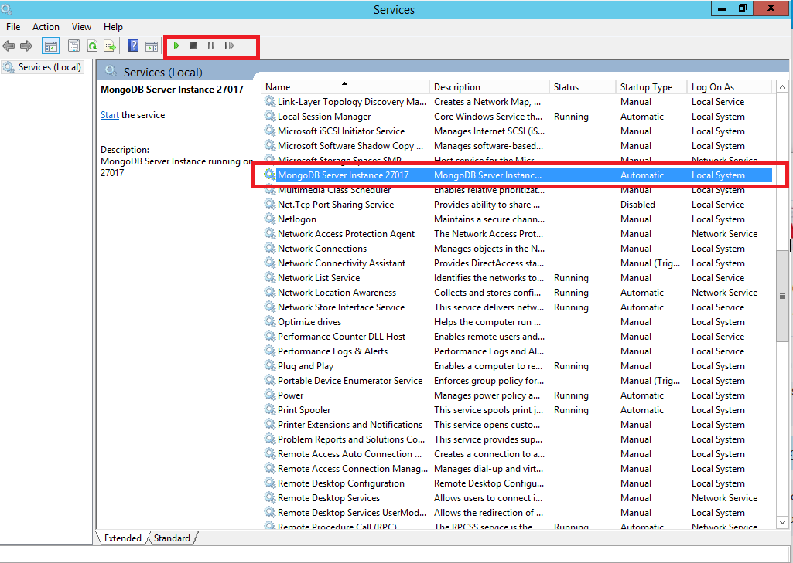

Illustration 16 Mongo configuration - Start the service

Once this is done, we have our database engine ready to work. In this section no safety issues were treated engine, so please read section 5 recommendations.

### R

R is the software responsible for conducting the climatic and agroclimatic forecasts. Using this tool we carry out the execution of the other components (CPT, DSSAT and Oryza) by system calls.

In the first window that displays R us installer will ask us the language. In this setting we recommend installation in English. After choosing the preferred language we press the OK button:

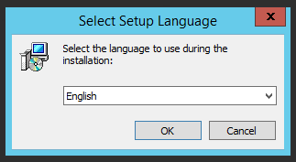

Illustration 17 Installing R - Select Language

In the next window a welcome window showing the version to be installed is displayed. In this part we press the Next button:

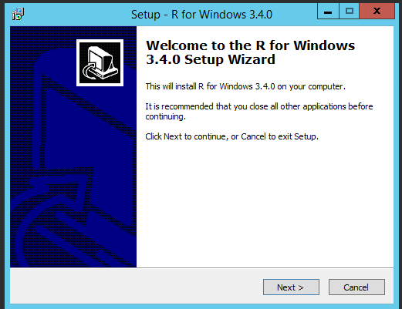

Illustration 18 Installing R - Welcome Window

In the next window we see the license R, in which when clicking the Next button, we will be accepting:

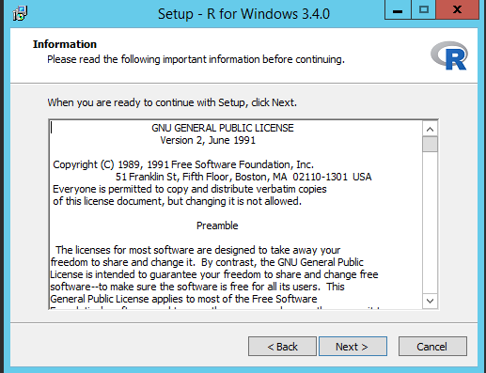

Illustration 19 Installing R - Software license

next step the installer will ask us where we want to leave the software files. This route can be changed, however, if you are not an expert, it is recommended to leave the default path. Pressed click the Next button:

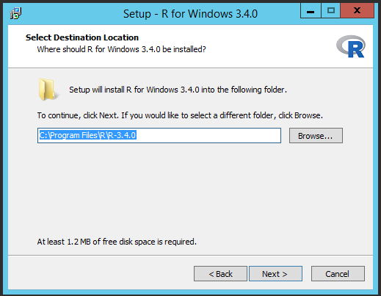

Illustration twenty Installing R - Software File path

The installer of R in the next window asks us about what components will be installed. We recommend leaving the default settings next. Pressed click the Next button:

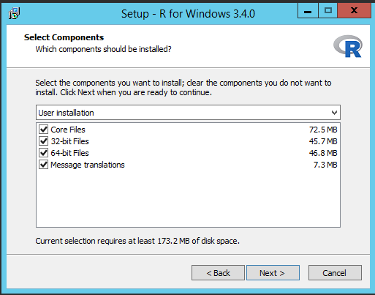

Illustration twenty-one Installing R - packages to install

In the next window we are asked if we want to customize the boot options, which let the options that come by default. In this part we choose the No option and press click the Next button:

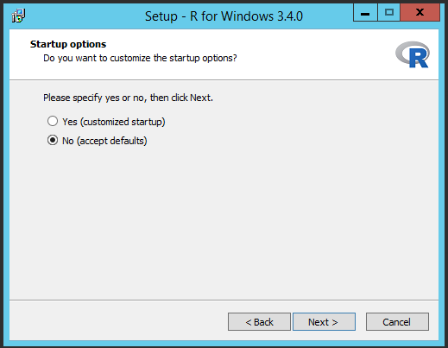

Illustration 22 Installing R - Startup Options

The next window asks us to put on a Shorcut there R programs in the Start menu. We leave default values ​​that come there and press the Next button:

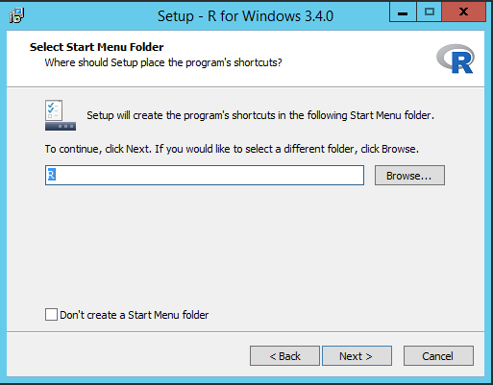

Illustration 2. 3 Installing R - Shorcuts

In the next window we are asked for some additional tasks installer. These options let default and press the Next button:

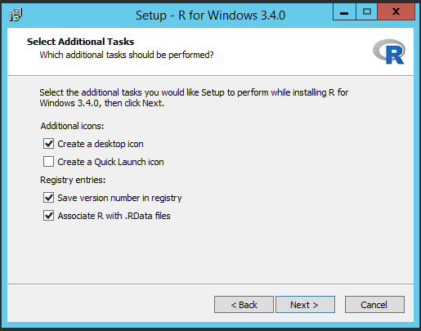

Illustration 24 Installing R - Additional tasks

The installer will start installing the components in the operating system. After installation will show a message confirming the installation. We press the Finish button:

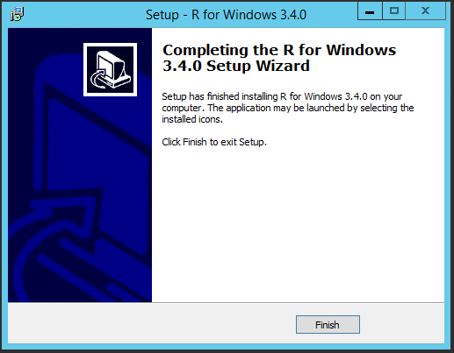

Illustration 25 R Installation - Installation Complete

### CPT

CPT[8]It is the tool that generates climate prediction. Note that you will install batch version rather than the graphical version. This release does not support directly with Windows server version, so you have to perform additional steps to resolve compatibility issues.

We must press right click the installer and choose the option Throubleshoot compatibility:

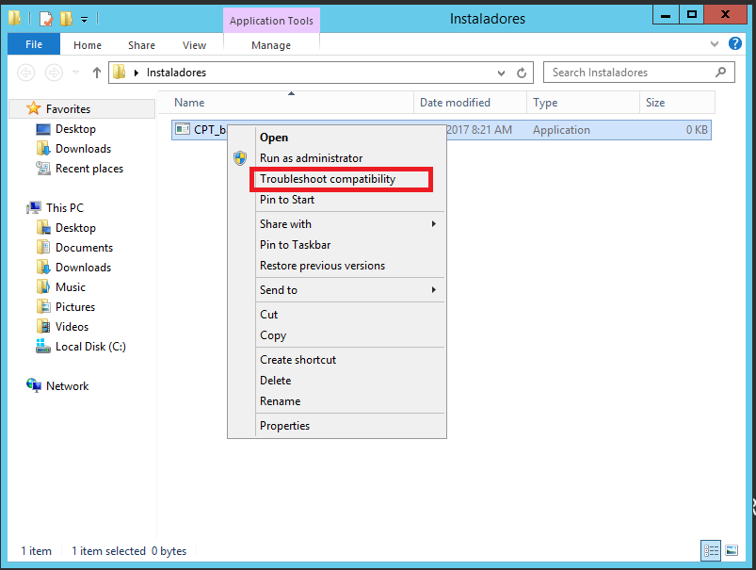

Illustration 26 Installing CPT - Troubleshooting Compatibility

The operating system will try to find a setting that fits this software, so we recommend Try recommended settings:

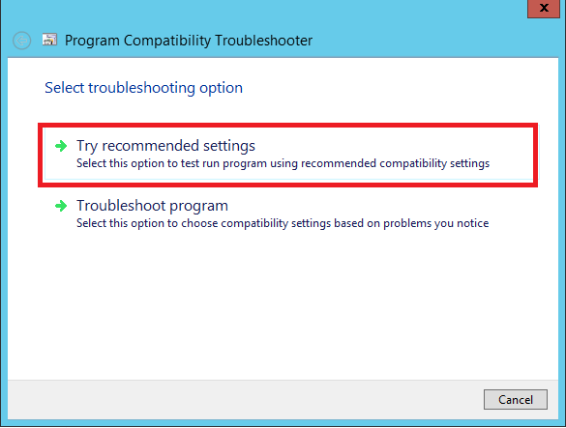

Illustration 27 - Installing CPT - Try recommended settings

In the next window asks us to make the system a compatibility test. In Windows Server 2012 R2 operating system must validate that take compatibility option how the Windows 8 or Windows 7 operating system, another CPT can not be properly installed. For this we press the Test button and the program then pressed click the Next button:

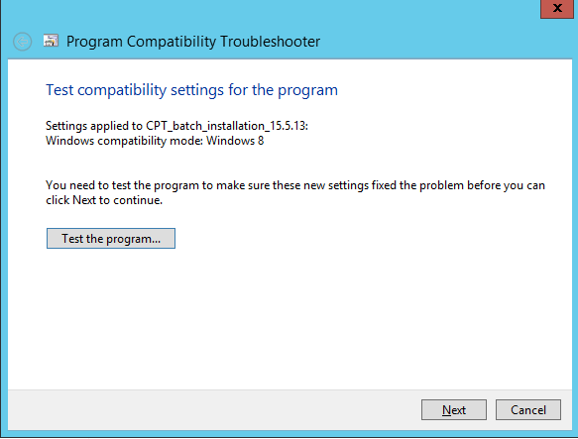

Illustration 28 Installing CPT - Compatibility Test

Since we are going to install an unknown program, the operating system shows global information packaging and we see if we run the installer. In this option we press the Run button:

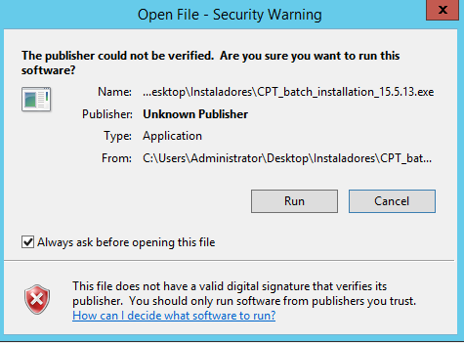

Illustration 29 Installing CPT - Authorization running the installer

The installer will start its execution and will display a welcome window and shows us the version of the software will install. In this window we press click on the Next button:

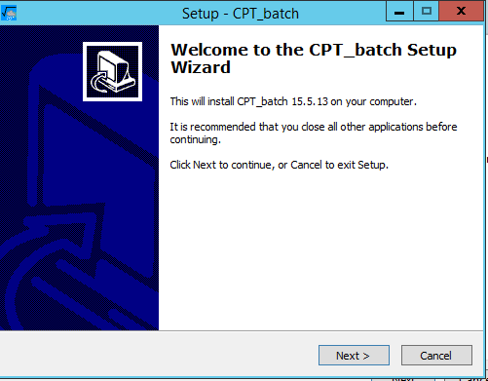

Illustration 30 Installing CPT - Welcome Window

We are shown in the window below us the license to use the software, which we must accept and then press the Next button:

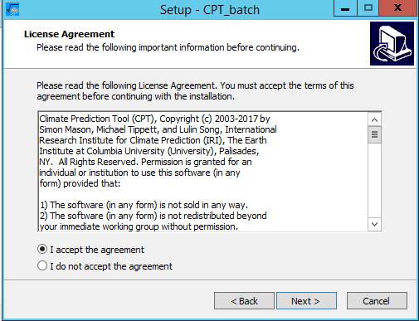

Illustration 31 Installing CPT - License

In the next window we are asked to indicate the route where it will be installed CPT programs, we recommend reroute default one and put it in C: \ Program Files \ CPT. After this we press the Next button:

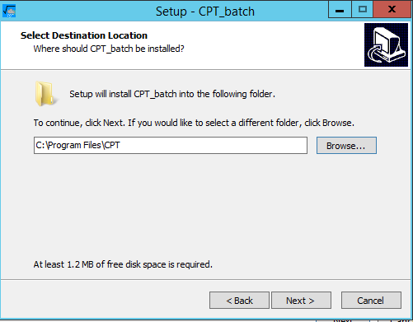

Illustration 32 Installing CPT - Target Path

In the next window installer asks us about what packages we want to include within the facility. Should not be an expert in the tool, we recommend installing all packages. Then we click on the Next button:

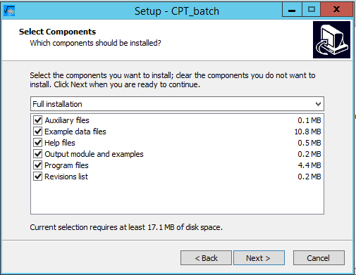

Illustration 33 CPT installation - Installation Components

In the next window we are consulted on the name of a folder to place the program shortcuts in the Start menu. This time we leave the defaults and press the Next button:

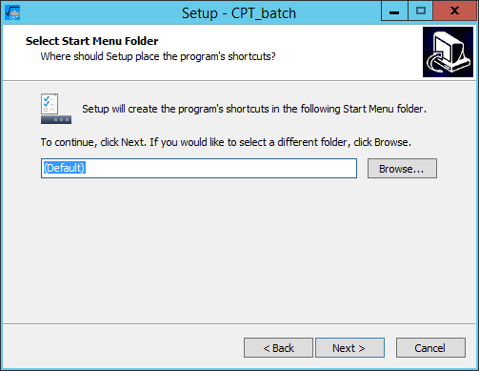

Illustration 3. 4 Installing CPT - Location shortcuts on the Start menu

In the next window installer asks us about some additional tasks. In this case we leave the default values ​​and we click on the Next button:

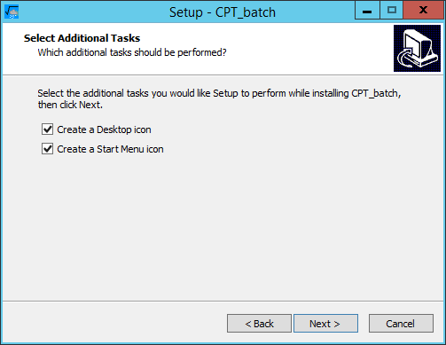

Illustration 35 Installing CPT - Additional tasks installer

We are shown us a summary of what will make the installer in the next window. In this window we click on the Install button:

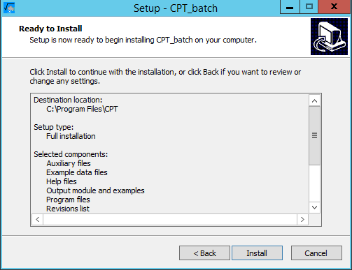

Illustration 36 CPT installation - Installation Summary

After installing the software components, the installer shows a message indicating that it has finished its work. In this window we press the Finish button:

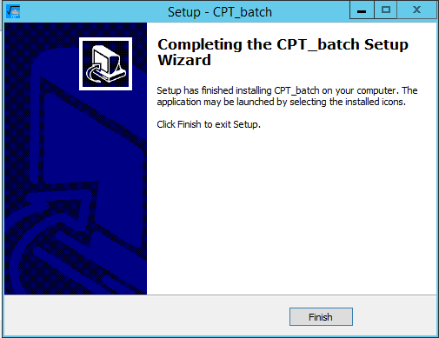

Illustration 37 CPT installation - Installation Confirmation

Upon completion of this process will be some open windows of our previous processes, if true the above statement, you can close the windows or failing to click on the Cancel button.

The next step is to record CPT files in the environment variables. The first variable is going to add Path. To make this process is necessary to access the system environment variables (see Figure 11 and 12). Once there we must add the path where you have installed CPT files to this, in the text field Variable value digitamos semicolon (;) and put the path: C: \ Program Files \ CPT. Once this is done we press click on the OK button:

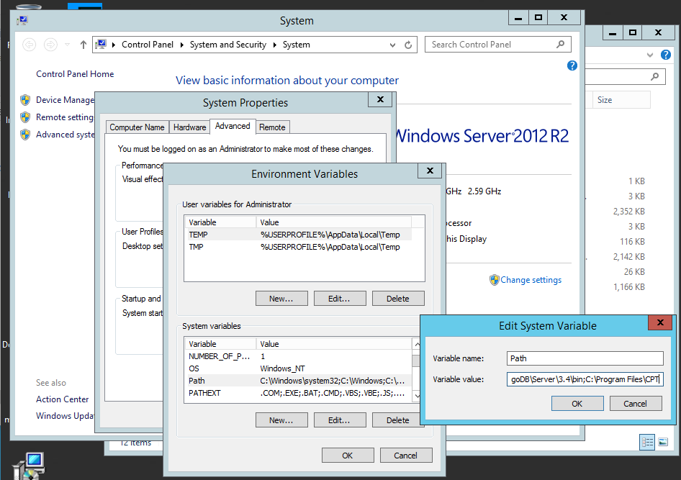

Illustration 38 Installing CPT - Add installation path Path environment variable

We must create a new environment variable called CPT_BIN_DIR. To make this process we must place in the Environment Variables window (Enviroment Variables) and press click on the New button in the text boxes must place the following information.:

* In the Variable field name = CPT_BIN_DIR
* In the Variable field value = C: \ Program Files \ CPT

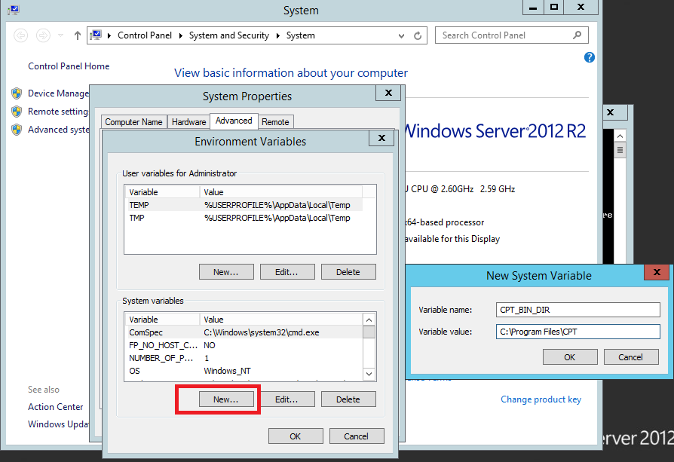

Illustration 39 Installing CPT - Adding Variable CPT_BIN_DIR

To close the Ok button pressed on the window.

We must ensure that we have successfully completed the registration of CPT in the environment variables. To test the configuration status must open a new window and type cmd there the following command:

*CPT_batch*

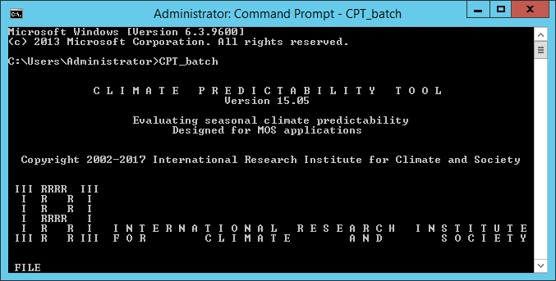

Illustration 40 CPT installation - Installation test

When you run the console should we display a message such as the Figure 40. With that validate that the tool was successfully installed.

### DSSAT

Decision Support System for Agrotechnology Transfer (DSSAT for short) is selected for modeling corn crop tool. This tool allows prediction crop performing a simulation of the given climatic variables and initial conditions.

To access this software must make a request on the official website of the software (<http://dssat.net/downloads/dssat-v46>). This process begins with the request for an email account for subsequent verification, ie mail to register there, you will be sent an email with a link in particular which will later access. Once confirm the account you will be requested some additional data, within which shall justify downloading this. When you finish fill out the form, you will receive an email in which he indicated that his application will be reviewed and after this will send a notification about where to download and assigned serial. The time it takes to get the download link and the serial is variable.

Once the mail arrives with the direction of discharge and software serial proceed to download. When we downloaded the software must unzip the contents to a folder. Following this we enter the unzipped folder and run the Setup. This will start searching for software requirements on the operating system:

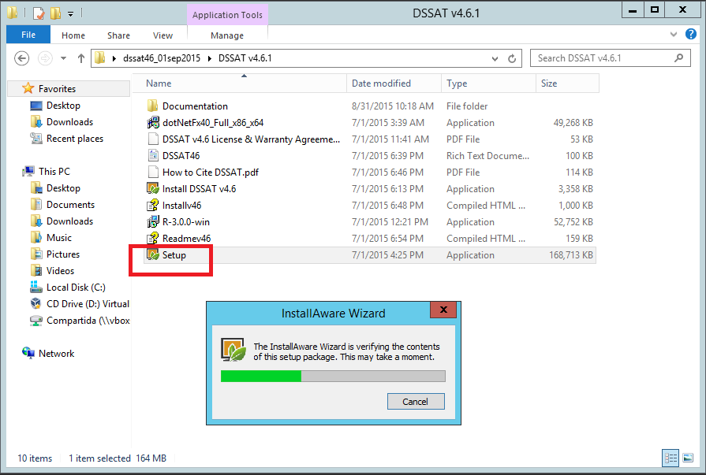

Illustration 41 DSSAT installation - Running Setup

We are shown in the window below us a welcome screen and the installation shows the software version installed. We press the Next button:

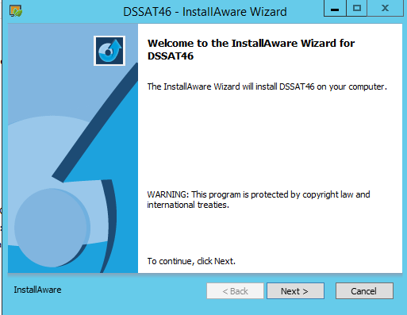

Illustration 42 Installing DSSAT - Welcome Screen

It shows us the license and terms of use in the next window. We must accept and press the Next button:

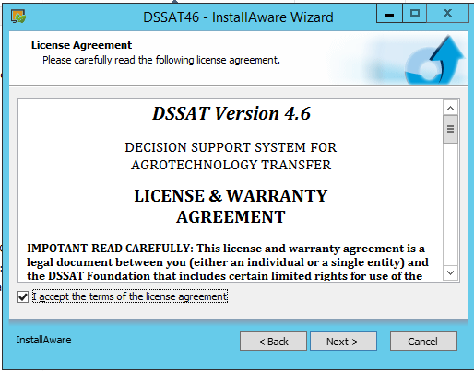

Illustration 43 DSSAT installation - Software License

In the next window we are requesting the path where you want to install the software. This section must preserve the data coming default. Pressed click the Next button:

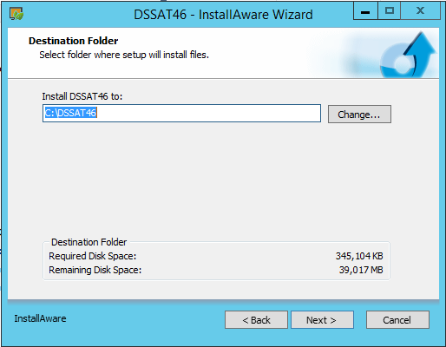

Illustration 44 DSSAT installation - Installation path

In the next window we are offered the possibility to change the folder for shortcuts and on users for which the application would be available. It recommends leaving the defaults. We press the Next button:

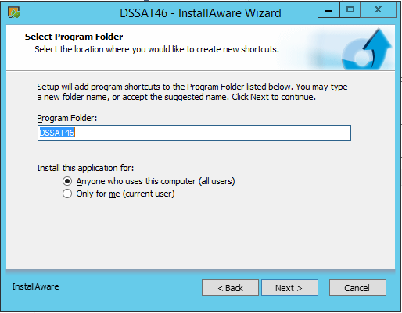

Illustration Four. Five Installing DSSAT - Shortcuts and availability for users

The system will proceed to install the software on your computer. Once the process is complete it will show a window confirming that it was successful. Pressed click on the Finish button:

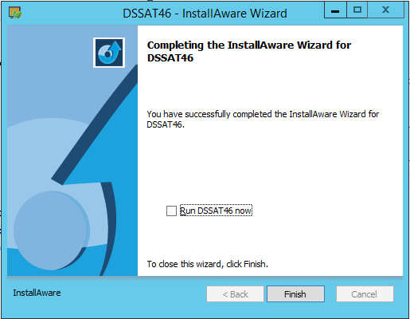

Illustration 46 DSSAT installation - Full installation

After installing the software must to register the serial we arrived by mail. For this we must open the DSSAT software, which will show us a window that asks us to enter the serial that is in an email that we got the download link. We press the Ok button:

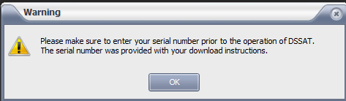

Illustration 47 Installing DSSAT - Alert message on the serial

We are after the previous window, displays a new pop-up window which asks us to enter the serial and additional data. We diligenciarlos and then press the OK button:

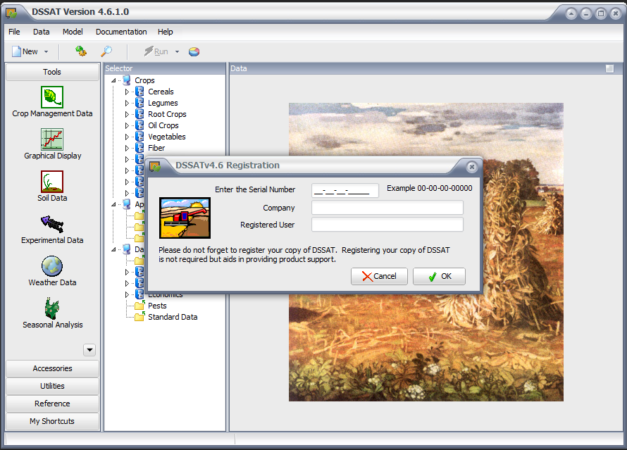

Illustration 48 DSSAT installation - Entering serial

The next step is to add to the Path environment variable installation path of DSSAT. To make this process must access the option Advanced system settings (see Figure 11 and 12). Once there we look for the Path variable and press the Edit button. We are located at the end of the Variable value field, add a semicolon (;) and finally put the path where the software was installed. Then we close all the windows by clicking the OK button:

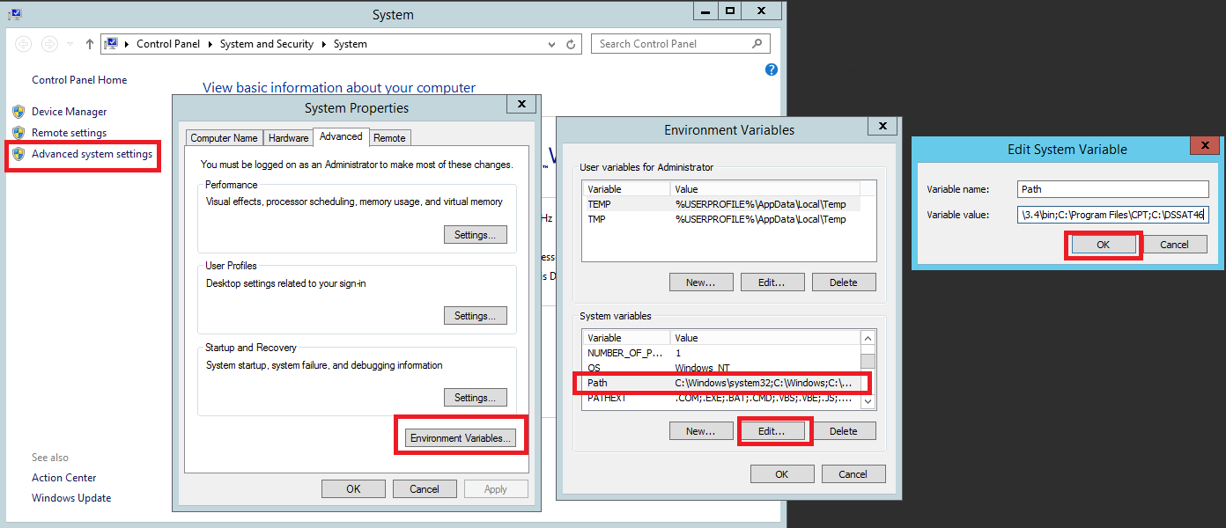

Illustration 49 Illustration DSSAT - Log installation on the environment variable Path

To verify that it is properly configured the system DSSAT open a console command (CMD) and run the following command there:

*dssat46*

This should open up a window of DSSAT ready to get started:

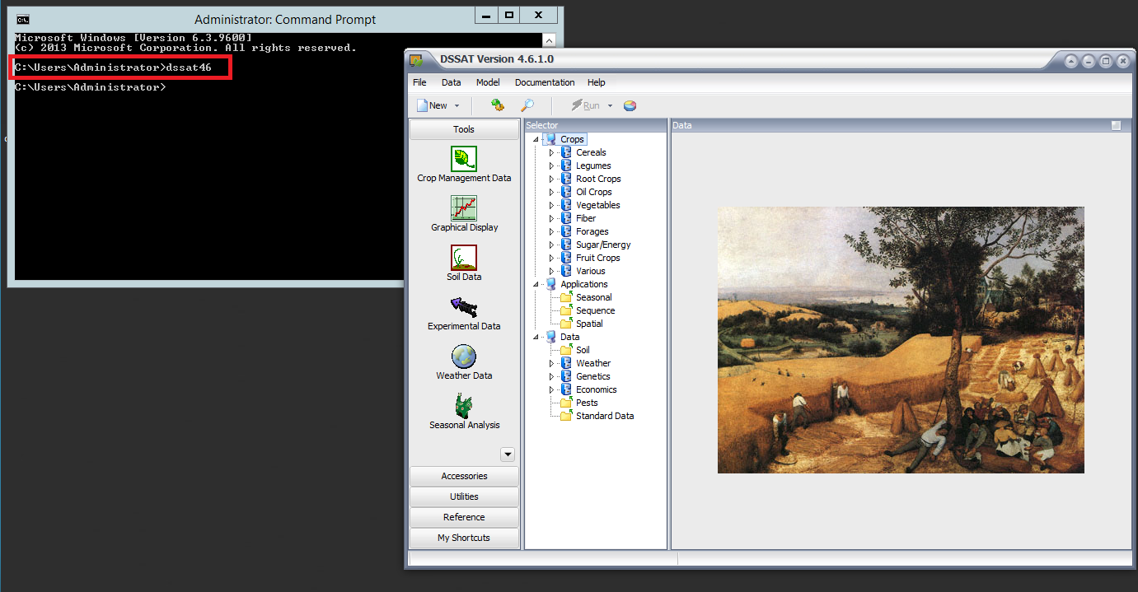

Illustration fifty DSSAT installation - Installation test

### Oryza

Oryza is a tool that has among its many tools allow modeling the behavior of the rice crop cycle. This software enables the platform to perform agroclimatic forecasts of growing crops, under different climate scenarios. Its function is very similar to the DSSAT. This software requires installed and enabled .Net framework 3.5[9].

To install this software must unzip the downloaded file. Once done the above, you seek the setup file and press double click on this:

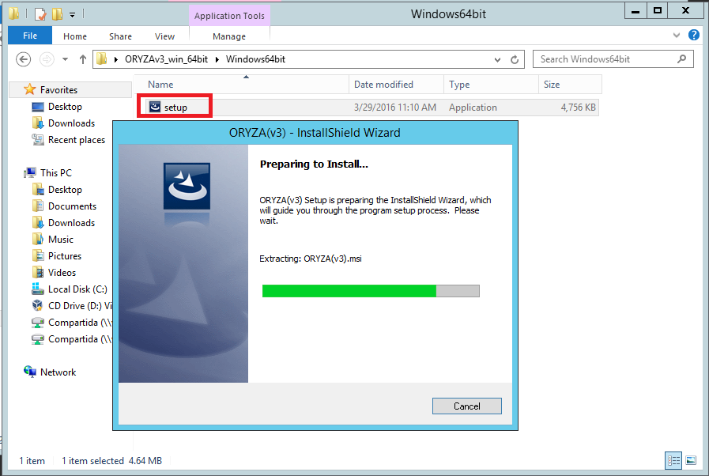

Illustration 51 Oryza installation - Setup

In the next window a welcome screen is displayed. This tells us the software version to be installed. We press the Next button:

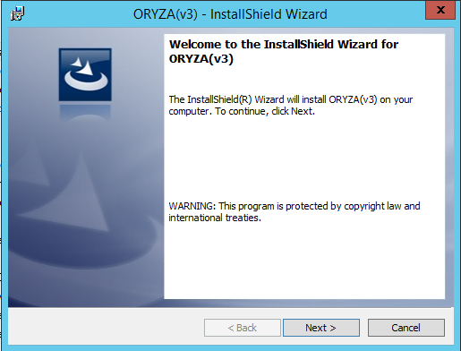

Illustration 52 Oryza installation - Welcome Screen

In the next window we displays the contents of the license. We must accept it and press the Next button:

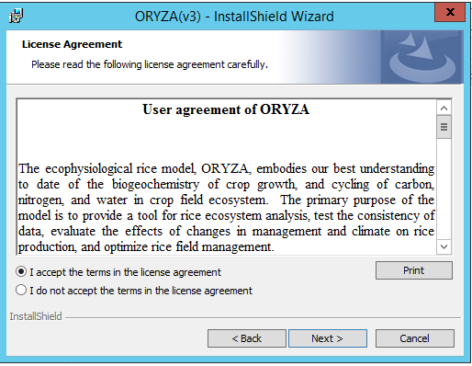

Illustration 53 Oryza installation - License

In the next window asking us to locate the software installation folder. It recommends leaving the values ​​that come by default. Click on the Next button:

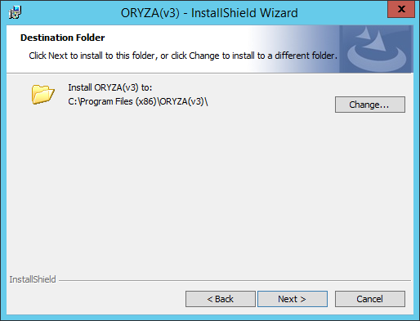

Illustration 54 Oryza installation - Installation path

We are shown a summary of the settings for this in the next window installation. Press click on the Install button:

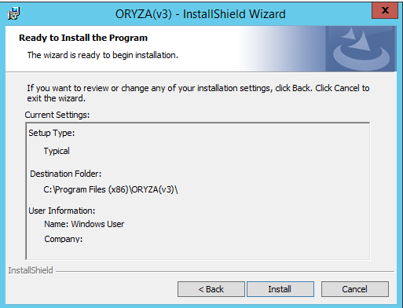

Illustration 55 Oryza installation - Installation Summary

In the next window a message that the installation has already been completed is shown. Pressed click on the Finish button:

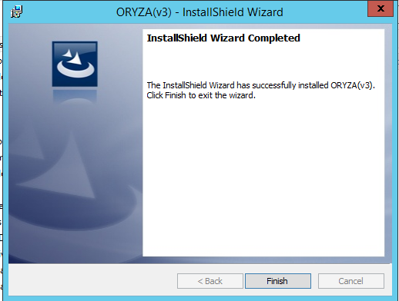

Illustration 56 Oryza installation - Message completion of the installation process

The next step is to add to the Path environment variable installation path of Oryza. To make this process must access the option Advanced system settings (see Figure 11 and 12). Once there we look for the Path variable and press the Edit button. We are located at the end of the Variable value field, add a semicolon (;) and finally put the path where the software was installed. Then we close all the windows by clicking the OK button:

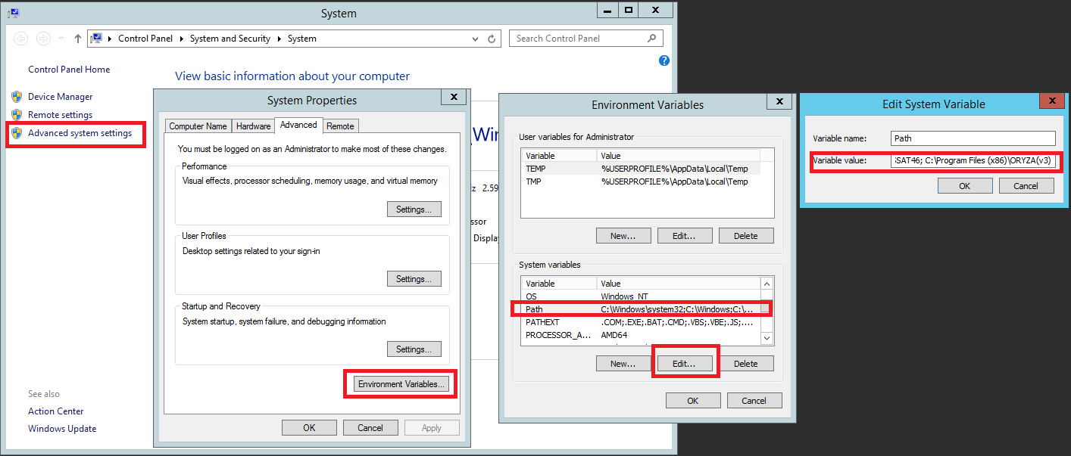

Illustration 57 Oryza installation - Registration environment variable

To verify that the software is properly installed open a command prompt (cmd) and there run the following command:

*oryza3*

In the window us a message should appear like the following to confirm that it has been properly installed:

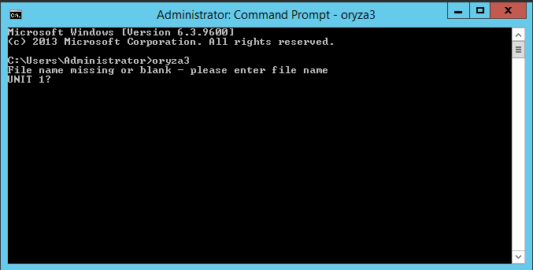

Illustration 58 Oryza installation - Installation test

# Website settings

In the official repository of source code platform forecasts can access download websites that are part of this. Every website has a purpose within the system. There is no requirement that all are installed on the same server, but what if you need to share, is access to the database in Mongo.

It is recommended to install websites in order to ensure that the platform work properly.

## PREPARING THE ENVIRONMENT

These web applications are built on .Net Core[10]. For deployments on Windows operating systems is required to have installed[11]active service and Internet Information Server (IIS). The version on which websites have IIS installed is 8.

Before you start installing applications we recommend creating a directory in which all websites will be located (if you do a distributed installation can create a folder on different servers). This folder should be at root level. In this implementation a folder named Websites is created in the root directory C. The final route in which websites are placed is: C: \ Websites. Something very important is to ensure that the user has permissions IIS_IUSRS this folder and all subfolders.

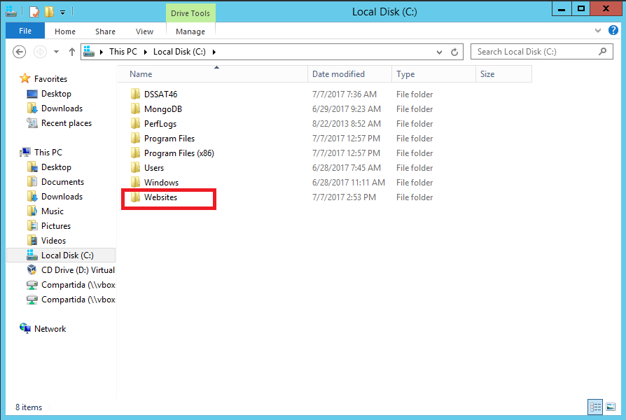

Illustration 59 Preparing the environment - Folder websites

Once configured the above, you need to create a profile in the Application Pools IIS. For this we will IIS and press the left menu right click on the Application Pools option, then click on the pop-up menu on Add Application Pool.

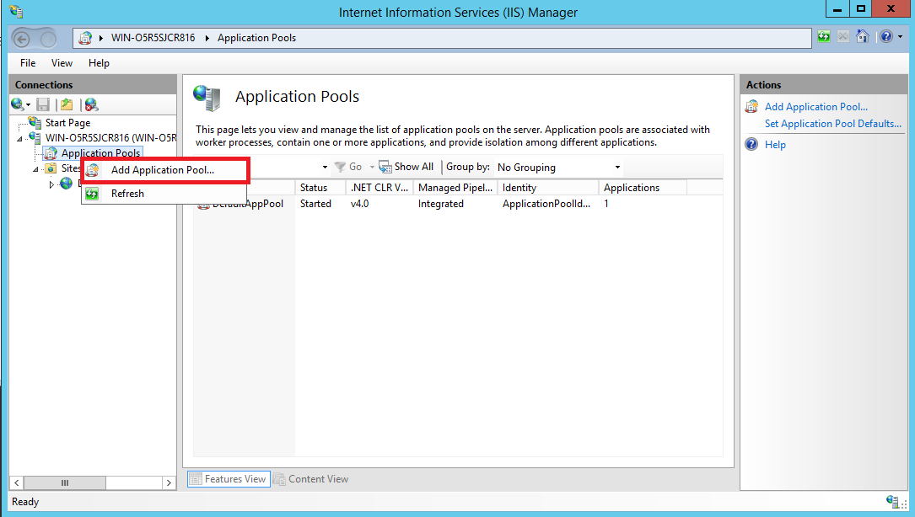

Illustration 60 Create configuration applicaton Pool

In the window that opens should place the following parameters to create the profile:

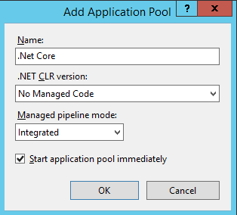

Illustration 61 Profile web applications

## WEB SITE MANAGEMENT

This website is responsible for the overall management of the platform parameters required to operate normally. This must be the first of three websites that should be installed. To install this web site must be downloaded from the source repository in the section Release (see the link in Requirements section). The website name is WebAdmin.

For installation on the server you must copy the folder inside the WebAdmin Websites that was previously created folder (C: \ WebSites). Once there should validate that the following folders exist within Data into the website: Log, Imports and Configuration.

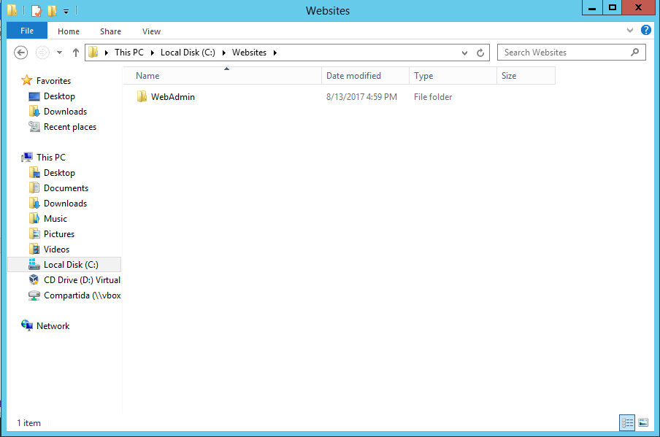

Illustration 62 WebAdmin folder

After setting up your website, you must edit the configuration file appsettings.json. The key parameter to configure is the ConnnectionString. This is the chain containing the connection to the database. The following is the format that must contain the connection string:

**mongodb: // user: password @ server: port / Database**

This file must also configure the Notification section. This section is used to set the parameters for an email account that is used for notification emails website when creating accounts. These data provider email service is given. All data are required.

Initially you should assign the value false Installed parameter. This is done to create the system administrator account, then we will change it.

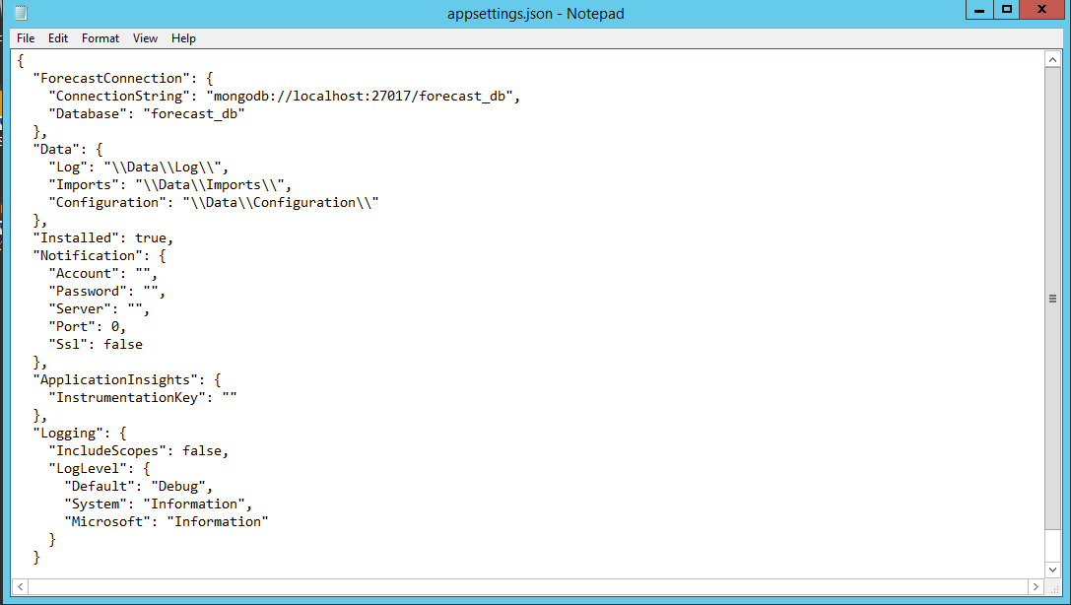

Illustration 63 appsettings.json file

Once this configuration has done you can proceed to place the available website. **Something very important is that this site can not be made public yet because it has not finished installing**. The first thing we do is create it as an application in IIS, but only in local mode. For this we will IIS on the left menu and look for the Sites folder. Once there we press right click and look for the Add Website option.

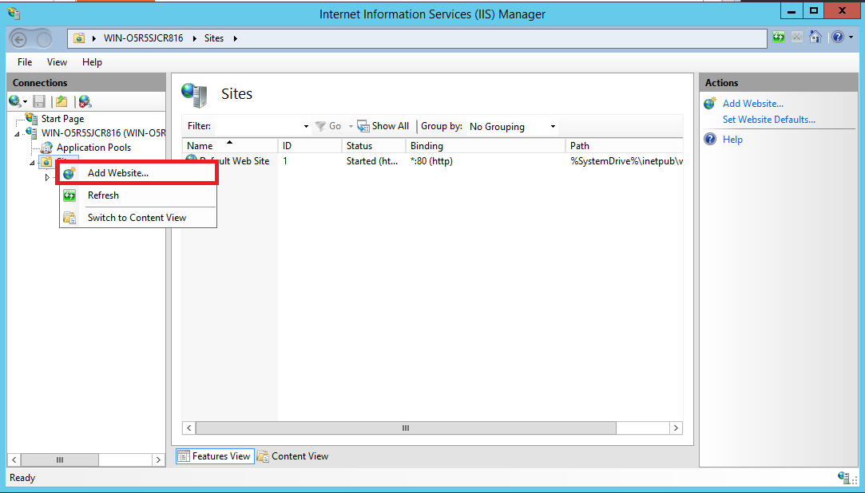

Illustration 64 Add new website (WebAdmin)

When performing the above process we deployed a new window in which we set the parameters for this website. We must place the name of the application, then we must select the Application pool the profile you created earlier called .Net Core. Then we look for the location of the application. Something very important here is the port where we want to place the application because the connections are made to the website will be through this, additionally it is recalled that should be added to the firewall port server to be available.

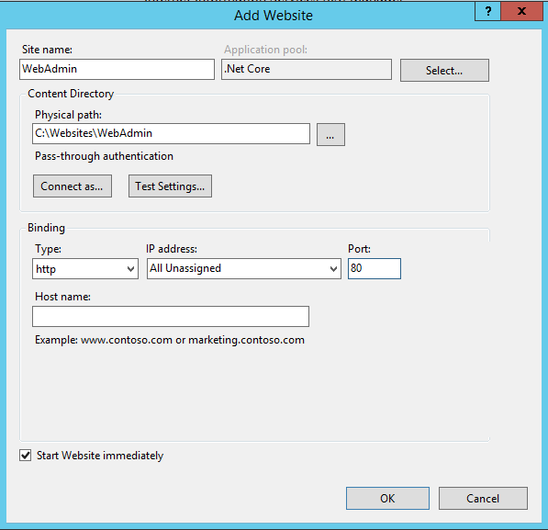

Illustration 65 WebAdmin configuration

Once this is done we go to the website through the browser. When entering we will find the configuration page, this is going to ask mail, password and a confirmation of this, to create the administrator account. By giving you install, the system will send an email to validate the account, to which we must give link click submit. By doing this opens a new window stating that the account was created successfully.

When we have completed this process we must return to appsettings.json configuration file and change the value of Installed parameter to true. Once this is done should restart the Web application in IIS. Now I have done this if you can leave the website available to the public.

## API WEB SITE

This website offers data stored in the database via web services. This should be the second application of the three websites that should be installed. To install this web site must be downloaded from the source repository in the section Release (see the link in Requirements section). The website name is WebAPI. For installation on the server you must copy the folder inside the WebAPI Websites that was previously created folder (C: \ WebSites). Once there there must validate the Log folder.

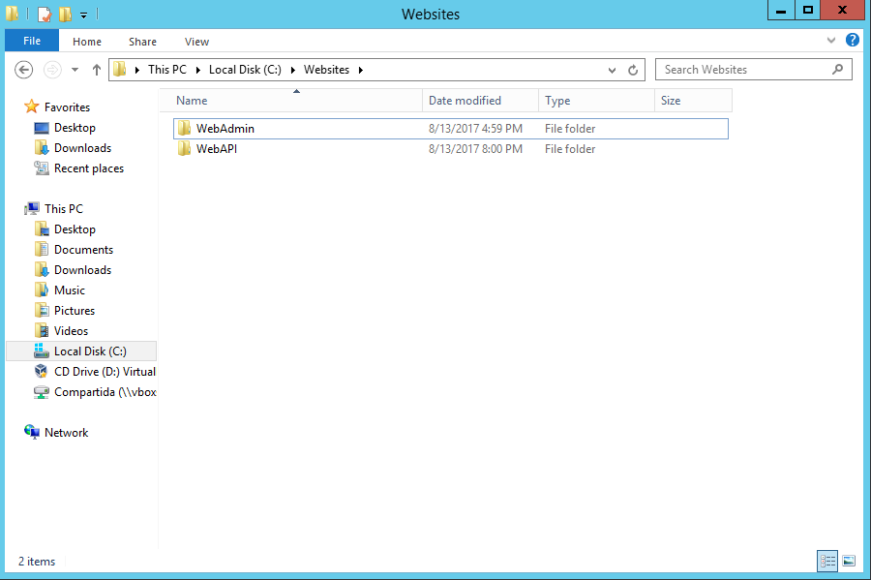

Illustration 66 Websites folder (WebAPI)

After setting up your website, you must edit the configuration file appsettings.json. The key parameter to configure is the ConnnectionString. This is the chain containing the connection to the database. The following is the format that must contain the connection string:

**mongodb: // user: password @ server: port / Database**

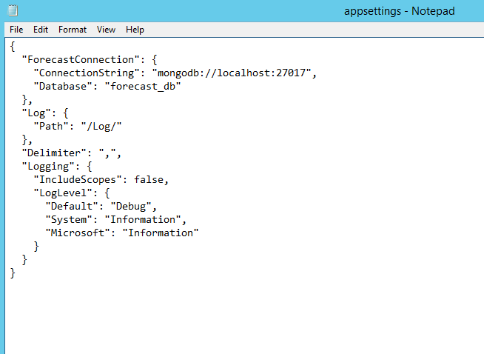

Illustration 67 Appsettings.json file (WebAPI)

Once you completed these steps you can proceed to create the application in IIS. You can follow the same steps that we use in shaping the administration Web site in the previous section. Unlike the administration website, this may be available to the public from the beginning.

## WEB SITE VIEWING FORECASTS

This website allows visualization of the data consuming services offered in the WebAPI. This site is not connected directly to the database. This should be the last of the three websites that should be installed. To install this web site must be downloaded from the source repository in the section Release (see the link in Requirements section). The name of the website is Web. For installation on the server you must copy the Web folder inside the folder Websites created earlier (C: \ WebSites). Once there there must validate the Log folder.

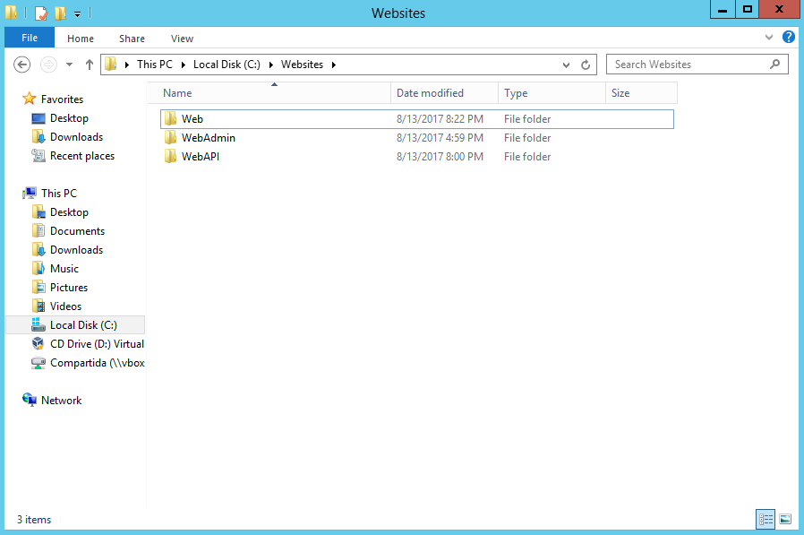

Illustration 68 Websites (Web)

After setting up your website, you must edit the configuration file appsettings.json. The key parameter to configure is the API_Forecast. This is the URL of the web service. You must be as follows:

**http (s): // server: port / api**

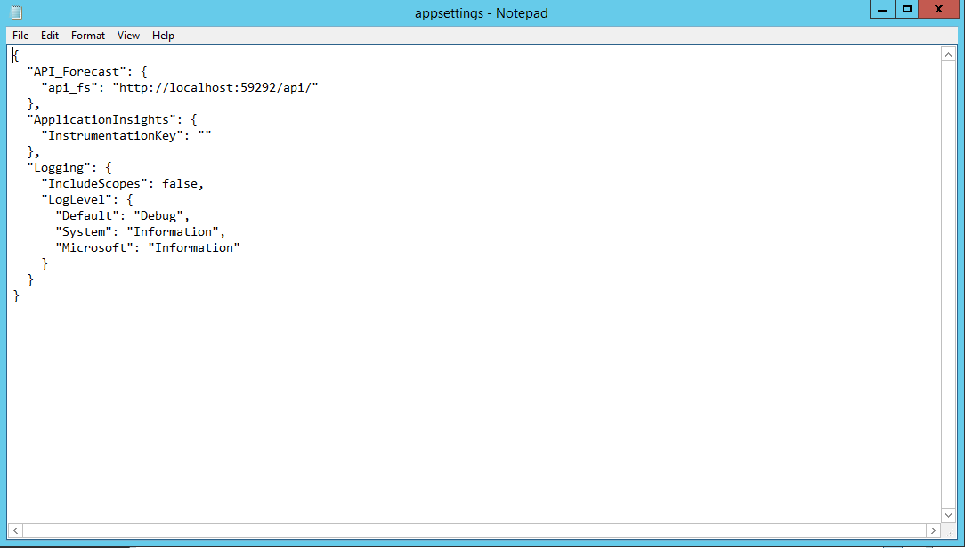

Illustration 69 Website configuration file

Once you completed these steps you can proceed to create the application in IIS. You can follow the same steps that we use in shaping the administration Web site in the previous section. Unlike the administration website, this may be available to the public from the beginning.

# SETTING generation process FORECASTS

# RECOMMENDATIONS

## SECURITY SETTINGS

## BACKUPS

1. Platform architecture agroclimatic forecasts
2. The server configuration was taken by the options offered by Amazon in its cloud computing service https://calculator.s3.amazonaws.com/index.html
3. Microsoft Visual C ++ 2015 Redistributable can be downloaded from <https://www.microsoft.com/en-us/download/details.aspx?id=52685>
4. Notepad is the default editor of the Windows operating system in Spanish is called Notepad
5. Environment variables are a set of dynamic values ​​that affect behavior
6. The cmd (Command Prompt Commands for short) is the program that lets you run commands on Windows operating systems.
7. System services can be searched in the Windows start button and it will appear under the name Local Services
8. Climate Predictability Tool (CPT in English)
9. .Net Framework to enable the visitor can: <https://technet.microsoft.com/en-us/library/dn482071.aspx>
10. .Net core is an open source implementation of .NET For more information: [https://www.microsoft.com/net/core](https://www.microsoft.com/net/core#windowsvs2017)
11. To install IIS can visit the following link: <https://docs.microsoft.com/en-us/iis/get-started/whats-new-in-iis-8/installing-iis-8-on-windows-server-2012>